
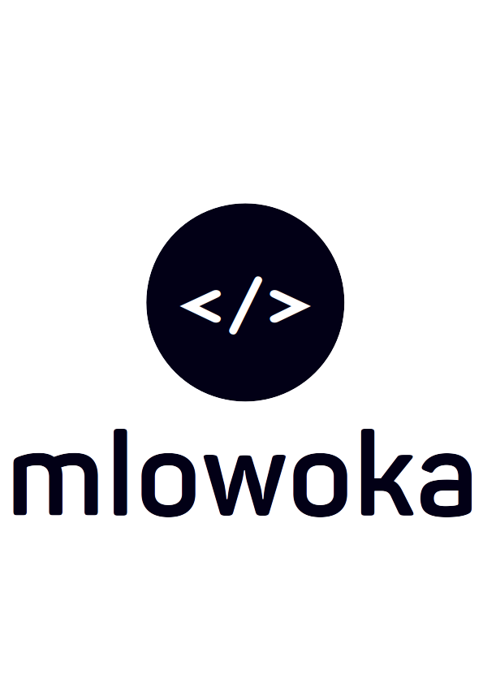
MCOMAT SYSTEM

MEMO NO. 1001

To: Administrator
From: John Kabatika Chirwa (Software Engineer)
Date: 30^{h} January, 2024
Subject: SCRUM MEETING ON STUDENT ACADEMIC INCREMENT REQUIREMENTS REFINEMENT

I write this memo to request a meeting tomorrow, 31st January 2024, at 1630 concerning the MCOMAT system being developed. The MCOMAT System is an information system currently only deploying student tasks in the academics section currently.

After being approved by the Managing Director, the system run a fast paced inquiry for tasks delegated to the Dean of Academics, Registrar, and Administrator that ensure to the successful accomplishments of students grades, storage, manipulation, and dissemination. Tomorrows meeting focuses on confirmation and approval of compromises from all parties on the the delegations as delegated in the system use case diagram produced. This will require participation from the following parties: registrar, dean of academics, and Administrator.

Your response to this sudden proposal will be gladly received. If the response will be of a further date, I will request you include the suggested date or week in your response.

Regards:
John Kabatika Chirwa
(Software Engineer)

CC: Registrar
Dean of Academics
Director

